HI-Ho cherry-o  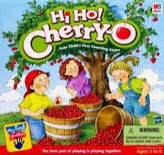  Basic Level  Ages: Pre-K- 5th grade | Pieces included in visuals  Rules for game  - Have a peer ask the student “What color do you want?” while pointing to the buckets  - The student will use the icons to answer, “I want the “X” bucket”  - Have each student put their apples on their tree  - Take turns spinning the spinner  - Using the visuals provided, have the student tell the group what they landed on  - The student plays based on what he has spun  - Continue to play the game until all the apples are off the first person’s tree  - At the end have the students either count the number of apples in the bucket or the number of apples left on the tree  Note:  - The dog and bird means add one to the tree from that child’s bucket  - Spill the bucket means put all the apples back on the tree  Additional Tips and Ideas  - Have the students add the cherries to the tree instead of taking them off

